“Roar Britannia?”

Bridget Deane

Figure 1. Philip Zec
Daily Mirror (London), January 16, 1942

This paper will focus on how it is possible to use editorial cartoons, from Australian and British newspapers, supported by newspaper reports, for discovering how events in the Far East (1941 – 1942) were perceived, not only by the cartoonists but also by the general public. In effect, the cartoons provide a commentary on the political (and war) situation at the time, reflect popular opinion, and sometimes manifest criticisms of Britain’s responsibilities towards its territories in South-East Asia as well as Australia. The work of the following cartoonists will be discussed: from Australia, Bill Mahony (Sydney Daily Telegraph), Mick Armstrong (The Argus) and Ian Gall (Courier Mail) and from Britain, Philip Zec (Daily Mirror), Sidney Strube (Daily Express) and Wyndham Robinson (The Star). This is just a small selection of the cartoons available; there were many other excellent cartoonists recording the events of the war, for example, David Low, Leslie Illingworth, and James McClelland, but unfortunately there is not space here to include their work.

Darracott (1989) explains that ‘All cartoons have value as historical evidence since they are documents in their own right; but like other written documents they require careful interpretation’ (p.143). Therefore it is necessary to keep in mind some questions when using editorial cartoons as a source: how accurately do the cartoons reflect the situation in the Far East, or what was known about events there? Are they a form of propaganda – official or unofficial? Can the cartoons be seen as entertainment and a way of encouraging or boosting the morale of readers or the population at large? What impact did the cartoons have when they were published? Perhaps that is the most difficult question to answer, as there is little evidence available, although a few caused controversy at the time they appeared, for example, Philip Zec’s ‘The price of petrol has been increased by one penny: Official’, which unintentionally offended Churchill and his government (Donald Zec, 2005).

Moreover, when decoding cartoons for the meaning embedded within them, it is important to recognise that we look at these drawings with the benefit of hindsight. We may have more, or less knowledge of the events concerned than the audience for whom they were intended. Also, we look at them from a different perspective, being so far removed from the time they were produced, in this case over sixty years; therefore our interpretation of the editorial cartoons may be different from that intended by the cartoonist. Additionally, as Bryant (2005) comments, it is difficult for us now to understand the
immense impact of cartoon art in pre-TV days … to a news-hungry public anxious about world affairs, the radio was a lifeline, but it was the political cartoon with its immediacy and universal accessibility - even to the barely literate – that could speak the message mere words could never convey
(p. 7).

The cartoons chosen concern events leading up to the fall of Singapore on 15 February 1942 and beyond. My interest in editorial cartoons of this period came through research I am undertaking into the evacuation of women and children from Malaya to Australia during the Second World War. It was literally by accident that my attention was caught by editorial cartoons in newspapers I was looking at. What attracted me first was the humour and quality of the artwork displayed in the drawings. Also I noticed how animals were used to represent the countries involved and the fact that they were instantly recognisable (although labels often provide additional information). Great Britain is a lion or bulldog, the latter particularly associated with Churchill who became Prime Minister in May 1940, but also with the phrase “the bulldog breed”, used to describe the British people; the bulldog, of course, bred as a fighting dog. Australia is seen as a kangaroo, lion or bulldog, the last two emphasising the close relationship between the dominion and mother country. Japan comes in a variety of guises – tiger, rising sun, ape, panther. Finally, I became aware of what an important source editorial cartoons can be for an historian. They add a dimension to the historical narrative that cannot be just expressed by words. As Roy Douglas (1990) comments, ‘… the cartoon often preserves a vitality which has been lost from factual accounts of events’ (p. xi).

Why the title “Roar Britannia?” Excuse the pun on the well-known song “Rule Britannia”. Lions roar and Britain was, and still is symbolised by a lion (three lions on a shirt – sporting teams). However, when it came to the defence of areas in the Far East, for example, Malaya, the lion seemed to have been caught napping (Fig.1). This lion was certainly not roaring; instead, it needed to wake up to the seriousness of events unfolding in the Far East.

Next “Britannia Rules the Waves”: at great expense a naval base had been constructed on Singapore Island. In times of emergency this was to house a British naval fleet and act as a deterrent for any country that considered acting aggressively towards British interests or the dominions of Australia and New Zealand – the “Singapore Strategy”. In late 1941 what was sent to Singapore was not the main fleet or even a ‘flying squadron’ of ships but Force Z, which consisted of six ships, (Murfett, 2002, pp. 16-18) including HMS Prince of Wales and HMS Repulse. The Royal Navy had always had a major role in the defence of Britain and its empire; now this was to be put to the test at Singapore.

The characterisation of the Royal Navy as a bulldog was used by a number of cartoonists, for example, Sidney Strube and Ian Gall. Note the gentle humour of Strube’s drawing (Fig. 2), compared to the aggressive stance that Gall has given his bulldog battleship, complete with spiked collar and guns bristling over the side (Fig. 3). ‘Jack' and ‘Syd’ are enjoying the success of HMAS Sydney’s sinking of an Italian cruiser, while a fierce bulldog ploughs through the waves in search of the enemy.

Figure 3. Ian Gall, Courier Mail, July 11, 1940

Figure 2. Sidney Strube
Daily Express, July 22, 1940

‘A STEP IN FRONT’ drawn by Bill Mahony, appeared on 4 December 1941, a few days before Japan launched its offensive. Here a bulldog is sitting on a step (Singapore) looking determinedly out to sea, and all under a gathering black cloud (threat from Japan). At the rear of the bulldog is a pillar (Australia) standing solidly behind Britain. The cartoon implies that the Royal Navy, based at Singapore would protect Australia, while the caption emphasises how important Singapore was to the defence of the country.
Figure 4. Sydney Daily Telegraph December 4, 1941 Bill Mahony

A report in the Sydney Morning Herald (Singapore Bastion, 7 December, 1941) praised the island - ‘But Singapore is much more than a naval base. It is an immense airbase and military garrison. Indeed it is the centre of British military and air power in the East.’ This assessment of Singapore’s strength was, as we now know, optimistic and inaccurate, but the newspaper was only reiterating propaganda about the ‘Gibraltar of the Far East’ (Warren, 2002, p9). As Ian Morrison (1943), war correspondent for The Times (London), wrote in his book Malayan Postscript:
By October 1941 the Singapore legend was really well established. British and American newspaper men had visited Singapore and written glowing articles about it. British statesmen talked confidently about its strength. It had become fashionable to refer to it as “the fortress of Singapore”, or often, as “the impregnable fortress of Singapore.” The legend had already achieved a world-wide currency (p. 3).

The role of the Navy was cut short, when on 10 December, 1941 the capital ships from Force Z, HMS Prince of Wales and Repulse, were sunk off the coast of Malaya following an aerial bombing attack by the Japanese; the defence of Malaya now rested with the army and airforce. However, by the end of December, the combined British, Australian and Indian forces were engaged in a defensive retreat down the Malaya peninsula. A report by a ‘special correspondent of the Australian Associated Press’ in the Hobart Mercury (Failures of Strategy, 23 December, 1941) summarised the situation:
After a fortnight of fighting we have lost Perlis, Kedah Province, Wellesley, Penang, and the north-eastern corner of Malaya … The people of Malaya are beginning to ask “Why?” For two years the people of Malaya, of Australia, and indeed of the whole world have been told time and again that the defences of Malaya were impregnable, yet in a short period strategic defensive areas have been lost and Singapore itself, the “world’s strongest fortress” has been put on the defensive, perhaps in jeopardy. …

Additionally, the Japanese had gained superiority in the air. Quite simply, the RAF (and RAAF) lacked fighter aeroplanes and were unable to offer much protection against enemy aerial attacks or provide air support for the land forces. This fact seems to have been well known in both Australia and Britain. The Sydney Daily Mirror declared that '“Singapore’s fate depends on planes. Unless adequate air reinforcements are made available promptly only a miracle can save Singapore”' (quoted in the Daily Mirror (London), If Singapore Falls …, 16 January, 1942). Richard Brown, a designer for an engineering works in Ipswich, commented in his diary that, ‘The stark damnable tragedy of the whole situation, too, is our lamentable weakness in the air’. He continued, ‘Someone ought to be disembowelled for that. Even in peace time it [Singapore] ought to be better defended’ (February 10, 1942). The news from the Far East (or ‘Near East’ if you lived in Australia) could not have filled the public in both Britain and Australia with confidence, especially after the surrender of Hong Kong on Christmas Day. There seemed to be no way of stopping the Japanese push southwards towards Singapore.

Interestingly, I have found no cartoons that allude to the ineffectiveness of the armed forces in Malaya. Perhaps it was taboo or an unwritten rule that there was no reference to military failure in editorial cartoons. After all, the cartoons were there primarily to entertain and raise a smile, not criticise the men of the forces. Military commanders, however, were openly criticised in the Australian and British newspapers, for example, Air Chief Marshal Brooke-Popham, Commander-in-Chief (Malaya) and later his replacement, General Pownall. The Daily Mirror (London) reported that Brooke-Popham had been
recently subjected to severe criticism in the Australian Press for his handling of affairs in Malaya since the Japanese attack began. The Sydney Daily Telegraph accused him of “fatuous optimism” and asked: “What mistakes must be made by high officers before they are sacked?”
(Our Far East C-in-C Sacked, Daily Mirror, December 27, 1941)

An editorial in the Daily Mirror (Singapore, January 13, 1942) commented,
General Pownall has announced that Singapore will be defended to the last. We believe him. Yet we may be excused if the familiar ring of defiant words does not convince us that mechanised battles can be won by bravado. Our hearts do not sink after such messages; they remain in a state of suspended animation governed by doubt. The doubt is: Have the Singapore Pukka Sahibs woken up too late?

Does this editorial reflect popular opinion about the news from Singapore? The article implies that people in Britain were not convinced by Pownall’s optimistic statement, and that the ‘Pukka Sahibs’, presumably meaning the British civil administration in Malaya, had reacted too slowly to the crisis facing them. Editorial cartoons provide further evidence of how the general public viewed the situation – although, perhaps the Press directing them what to think.

In fact the colonial administration in Malaya came under fierce attack from the Press and others for its lack of action and forethought during the defence and retreat down the peninsula to Singapore. Certainly the British in Malaya were seen as running away, leaving the armed forces to sort out the mess as the cartoon below demonstrates (Fig.5).

Figure 5. The Star (London) January 13, 1942,
Wyndham Robinson

According to an article in The Argus ("Purge of Pansies", 6 January, 1942) a British MP, Ness Edwards, called for a ‘“purge of pansies” from responsible positions in overseas territories’. It was these ‘“hyphenated be-monocled school-tie wallahs”’ who were to blame for the lack in preparation of Far East defences. Sir Charles Brook, White Rajah of Sarawak expressed similar views. He called for the sacking of ‘Singapore brass-hats, old-school-tie, la-di-da incompetents and others responsible for the fantastic Malaya position’, so reported the Daily Express (London). ‘“People will be out for somebody’s blood over this awful mess,” he said … “There will be a tremendous flare-up in England”’ (Rajah Forecasts "flare-up", 16 January, 1942)

Figure 6 is a visual example of how the colonial administration was perceived: two portly wallahs find themselves ‘in a bit of a spot’, bound up in the fuse for a bomb (Singapore). The caption ‘CAME THE DAWN’ is very apt, describing the realisation that the situation in Malaya was very serious and that Singapore was under great threat. This view is borne out by the cartoon in Figure7 where a little bird cowers under the leering tiger (Japan). The label (‘underestimation’) sums up very neatly that the assessment of Japanese capabilities had been misguided. Note how the tiger has been drawn with instantly recognisable features – slanted eyes, goofy teeth and a moustache – that is how the enemy were caricaturised at the time and reflects the general perception that people had of them: ‘Popular cartoon images of the Japanese promoted the idea of tiny, strutting men in glasses brandishing swords, with buck-tooth grins and slanted slits for eyes’ (Warren, 2002, p. 46). The caricature of Japanese in cartoons and posters as a myopic, grinning buffoons actually turned out to be highly inaccurate; Japanese soldiers were well trained, disciplined fighters much to the surprise of the Allied forces who faced them.
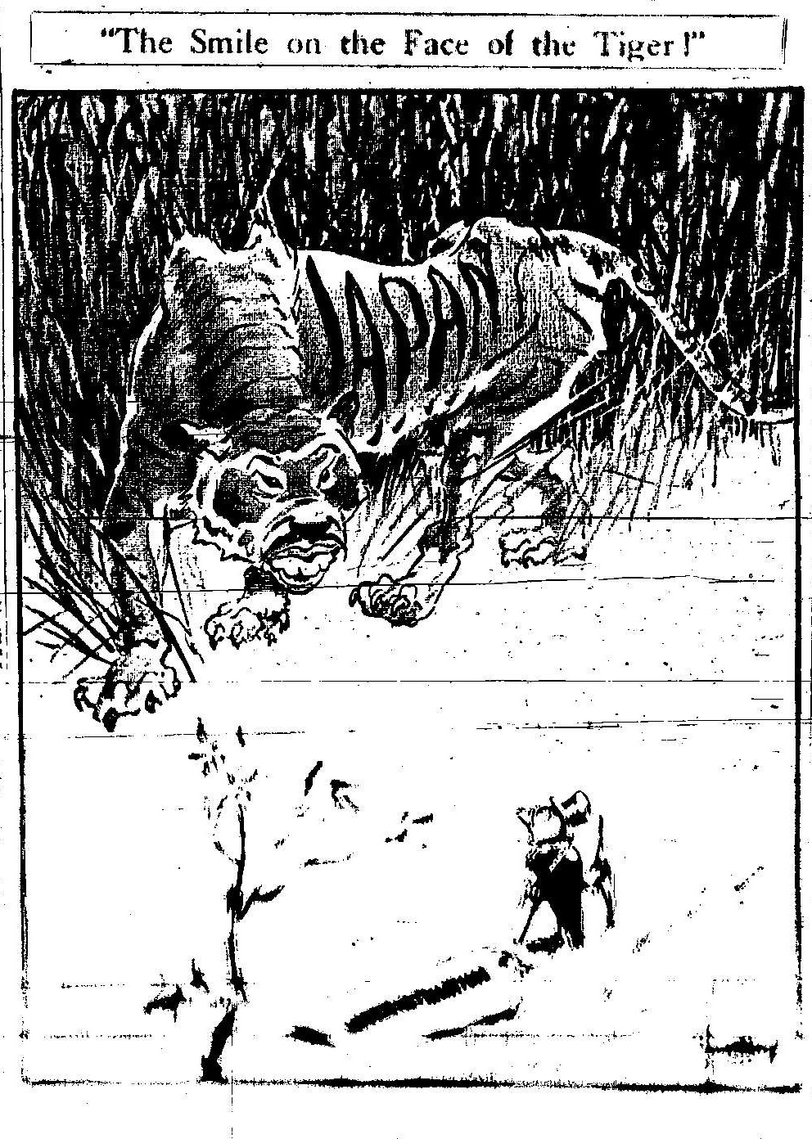
Figure 7. The Argus, January 12, 1942 Mick Armstrong
The label attached to the bird reads
‘UNDERESTIMATION’

Figure 6. Sydney Daily Telegraph, January 16, 1942
Bill Mahony
Written under the two wallahs is
‘OPTIMISITC ADMINISTRATION’
Figure 7. The Argus, January 12, 1942 Mick Armstrong
The label attached to the bird reads
‘UNDERESTIMATION’

Also, a number of journalists were critical of British people living in Malaya, including Ian Morrison (1943) but most notably Cecil Brown, an American reporter. One of his articles “The City of Blimps, apathetic and unprepared” was reproduced by the Daily Express (14 January, 1942), in defiance of a ban by military authorities on the publication or broadcast of any of his work. This piece seems to be the origin for the whisky-swilling sahib stereotype, and provoked a response from L.D. Gammas, MP and former Malayan civil servant:
All this talk about whisky swilling by rubber planters, tin miners and blimpish civil servants is a disgraceful thing. … If Malaya is unable to hold off the invaders today it is not their fault but the fault of the Home country’s one-sided disarmament policy for 20 years after the last war. Now is the time to send men, guns, tanks and warplanes to Malaya and to stop wrongly criticising our fellow-countrymen there.
(Quoted in the Straits Times, British Community in Malaya Championed, 20 January, 1942)

Elphick (1995) makes an interesting point about newspaper reports concerning the behaviour of European residents of Singapore, suggesting that these stories were started by ‘certain British newspaper correspondents out to make a good copy, …’ (p. 276). No doubt the readers of these newspapers would have been influenced by these reports as well as the visual images provided by editorial cartoons in their assessment of the British in Malaya. But how accurate was this assessment?

The Civil Defence of Malaya, collated by Sir George Maxwell (1946), gives a detailed description of the roles played by British men and women in the battle to stop the Japanese advance down the Malayan peninsula; the majority of men were involved in civil defence or the volunteer forces (army, navy and airforce), while many women contributed as nursing auxiliaries, manning first aid posts and blood transfusion units, and working in canteens and social clubs for soldiers as well as fund raising activities. While it cannot be ignored that there were some who contributed little to the war effort, overall the majority did. Therefore, it was not without cause that Sir George Maxwell admonished the British public for the way in which

in complete ignorance of the facts, it abused indiscriminately the civil servants, the planters, the European women, the Malays, and the entire civilian community for what was, from beginning to end, a military disaster due to lack of military preparedness and adequate military forces. The feeling was cowardly, mean, and thoroughly un-British. … (p. 90)

This book was written with the intention of setting the record straight and expresses the indignation felt by many British ‘Malayans’ for the way in which they were blamed for the fall of Singapore. It would be fair to say that the image of colonial men and women dining and dancing away at Raffles Hotel, oblivious to the war around them, is still perpetuated, but is this an truthful representation or somewhat superficial?

For Australia, the successful defence of Singapore was paramount to the safety of the country. As Beaumont (1996) comments the country’s defences ‘were fearfully thin’ (p. 26); with the four AIF divisions overseas - three in the Middle and the fourth division was scattered across Ambon, Timor, New Britain, and Malaya (two brigades) - this left the Militia to defend Australia (Beaumont, 1996). However, Britain’s priorities lay with the war in Europe and particularly the Middle East, an area into which reinforcements, armaments and aeroplanes had been directed, leaving Far East defence vulnerable, not only in Malaya, but also Hong Kong and Burma. A cartoon by Zec (Fig. 8) illustrates Australia’s frustration in trying to get Britain to face up to its responsibility it had for the security of the Dominion. Threatened by an ape (Japan) trying to knock down the partition wall between the cages, the kangaroo is attempting to attract the attention of the dozing lion; unfortunately it has a “DO NOT DISTURB” sign up. The irate expression on the face of the Kangaroo conveys the exasperation felt by the Australian Government and people for Britain’s inaction far better than words could. This cartoon was seen by a British audience – would it have
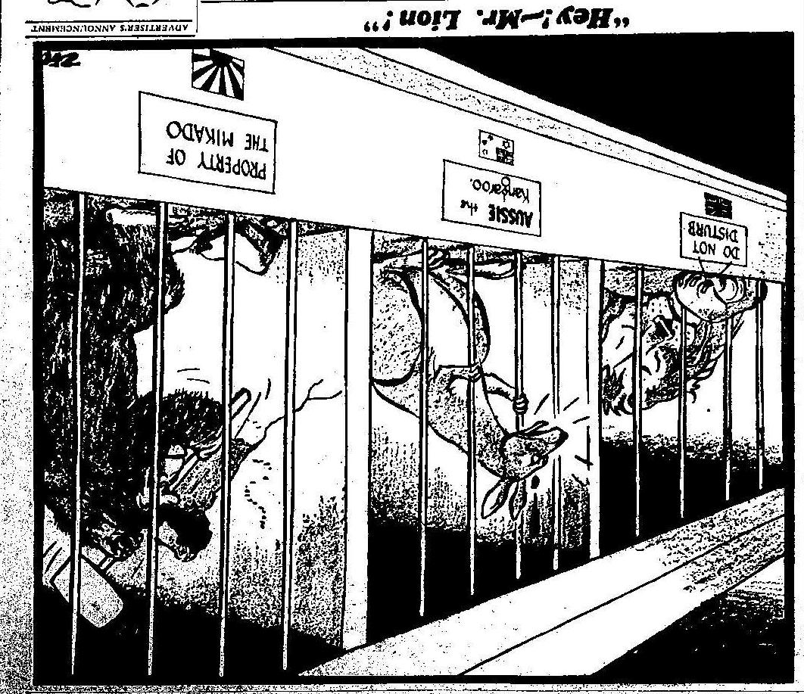
Figure 8. Philip Zec, Daily Mirror (London)
January 24, 1942

provoked a reaction from them, and if so, what kind? A report in the Daily Mirror, entitled ‘Australia praises us’ (January 15, 1942) may shed some light on this. In this extract, the Mirror is quoting from an Australian newspaper from the previous day:

In a leading article the [Sydney] Sun states “the courageous British newspapers are uniting in a strong effort to shock Whitehall and the British public into a better realisation of what the loss of Malaya means to the Empire.”

With this in mind, perhaps the purpose of Zec’s cartoon was to bring to the public’s attention what the loss of Malaya would mean, more specifically, to Australia - that it would be under direct threat from Japan.

Despite the accusations of incompetence thrown at both the military and civil administration in Malaya, there still remained the hope that Singapore would be held and defended to the last. A cartoon by Strube illustrates this (Fig. 9), showing a lion poised to repel advancing panthers (Japan). Note the squadron of dragonflies in support of the panthers. By the beginning of February, when this cartoon was published, it seemed inevitable that Singapore would fall – the causeway between the island and mainland had been blown up in a bid to slow down the Japanese advance. How long ‘Fortress Singapore’ could hold out was a matter of speculation, but the roaring, aggressive, lion pictured here would surely suggest to readers of the newspaper that the Imperial forces (British, Australian and Indian troops) would be giving their all in defending Singapore.
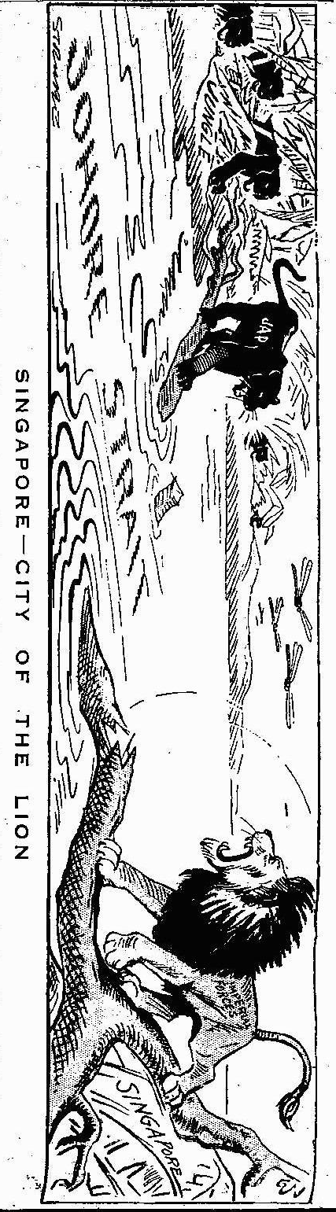
Figure 9. Daily Express, February 3, 1942 Sidney Strube

However, on 15 February, 1942 General Percival surrendered to Japanese forces with allied losses (killed and captured) of 138, 708 (Connaughton, 1994, p. 32). Why and how had the impregnable fortress of Singapore been lost so easily? The Australians blamed the British; the British blamed the Australians; the British blamed the British … in fact it would probably be fair to say that the rest of the world, including the Axis powers, pointed the finger at Britain. As Murfett (2002) comments,

Scapegoats are invariably needed when disasters occur. And, alas, the British do fit the bill – not least because many people (and not just those from the Australasian Dominions) depended upon them for their defence and survival and in the end – not matter which way you cut it – the British let them down. This is not empty populist rhetoric – it sadly happens to be an indisputable fact of life’ (pp. 20-21).

The bulldog was in the doghouse, the lion was no longer king of the jungle. Cartoonists now turned their attention to Australia and the continuation of the battle against Japan.

The cartoons below, one Australian and one British, show Australia’s determination to keep fighting, yet the way in which the country is portrayed there is a notable difference in the approach of the cartoonists.
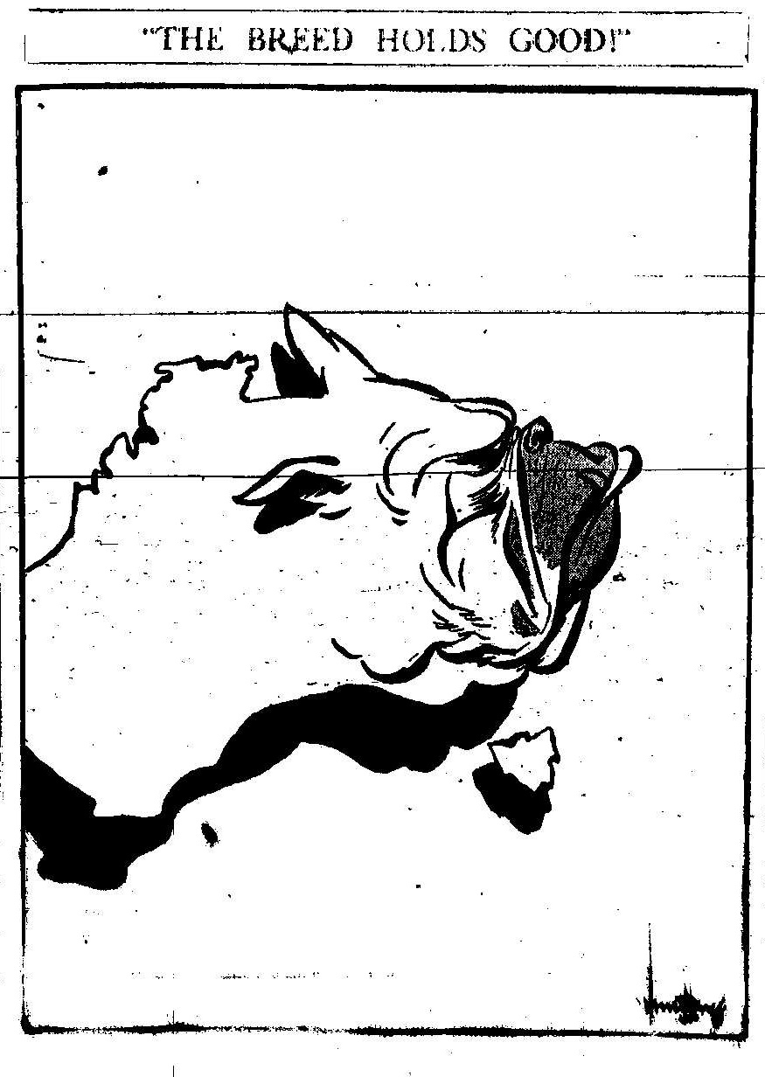
Figure 11. The Argus, March 17, 1942
Mick Armstrong

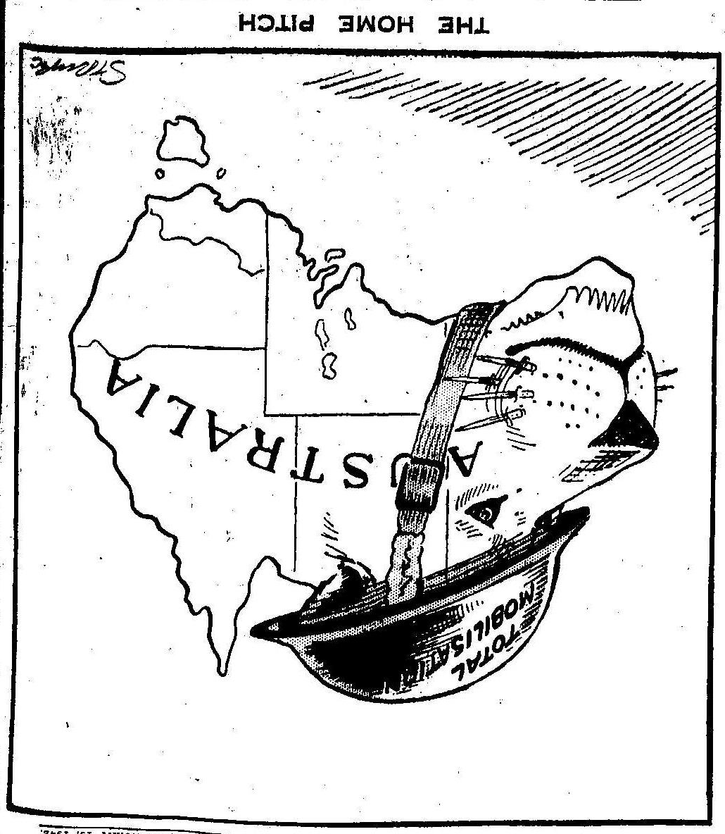
Figure 10. Daily Express, February 19, 1942 Sidney Strube

In Figure 10, Strube has created a lion’s head out of western Australia – a rather handsome fellow. On a tin hat, set at a rakish angle, are the words ‘total mobilisation’, and its whiskers are bayonets; this lion is ready and waiting. Note also the sporting analogy in the title of the cartoon – ‘THE HOME PITCH’ – Australia now found itself on the front line. A lion has been used to characterise Australia, linking the country back to Britain. Would this lion be a formidable enemy for the Japanese? For me, the bulldog, drawn by Mick Armstrong, looks like a much more fierce some opponent (Figure 11). This time, the east side of Australia has been used to create the animal’s face, and the country looks angled, so the bulldog – an ugly specimen – is looking up towards Japan, a tooth showing and bottom lip protruding. The title of the cartoon ‘THE BREED HOLDS GOOD!’ suggests that Australians are showing the same determination and spirit as the British population, stoically defending their island against Nazi Germany. It is interesting that the Australian cartoonist, Armstrong, has chosen a bulldog to represent his country, whereas Strube has used the lion. Was it the aggressive nature of the bulldog that appealed, rather than the British (imperial) lion which had lost its roar and prestige with the fall of Singapore?

Editorial cartoons relating to the invasion of Malaya and subsequent fall of Singapore bring colour to written accounts of this episode during the Second World War. It is through contemporary newspaper reports as well as the cartoons that we can gain an understanding of what the general public in both Australia and Britain knew of events taking place in the Far East. What is emphasised in the cartoons used for this paper is that at the time, it was the civil administration that was blamed for the disastrous defence of Malaya. However, it should be taken in to account that the Press had a hand in apportioning the blame. Next in line was the Britain itself, represented by the sleeping lion, which needed to be roused from its snoozing to take responsibility for the security of its territories and dominions in the Far East. As Murfett (2002) points out it was the British who were responsible for the loss of Singapore. It is also clear from these editorial cartoons that the ties between Australia and Britain were strong, despite the fall of Singapore and the feeling that British had let everyone down badly. The use of the lion or bulldog to characterise each country expresses the close familial relationship between them.

Finally, these cartoons were primarily to entertain, but they also gave praise or criticised. They were not part of the official propaganda campaign in either country yet they would have encouraged morale and influence opinion, but they did not intentionally mislead or misinform the public; rather the editorial cartoon reflects what was known about the situation in the Far East at that time and illustrate this for their audience. Darracott (1989) comments that 'Cartoons can have a part in widening the range of our understanding of the past …' (p.150). Moreover, for a researcher the drawings and captions illuminate the written record, provoke thoughts and questions and raise a smile, just as was originally intended by the cartoonists who created them.

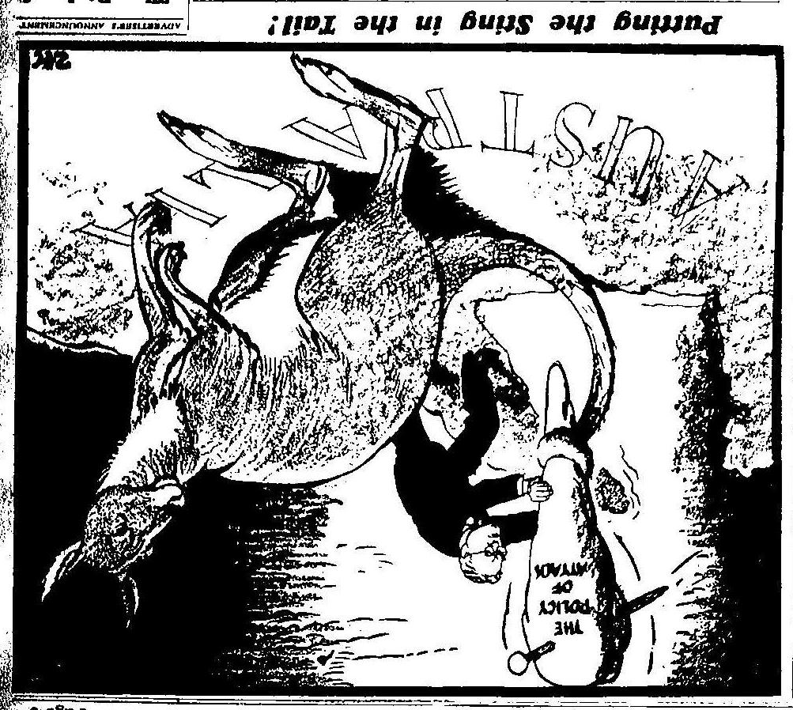
Figure 12. Daily Mirror (London) March 26, 1942,
Philip Zec

References

Newspaper Articles
Singapore Bastion (December 7, 1941) Sydney Morning Herald
Our Far East C-in-C Sacked (December 27, 1941) Daily Mirror,
Failures of Strategy (December 23, 1941) Hobart Mercury
"Purge of Pansies" suggested by British MP (January 6, 1942) The Argus
Singapore (January 13, 1942) Daily Mirror (London)
Australia praises us (January 15, 1942) Daily Mirror (London)
The City of Blimps, apathetic and unprepared (January 14, 1942) Daily Express (London)
Rajah forecasts "flare-up"(January 16, 1942) Daily Express (London)
If Singapore Falls … (January 16, 1942) Daily Mirror (London)
British Community in Malaya Championed (January 20, 1942) Straits Times (Singapore)

Books
Beaumont, Joan. (1996). Australia's War: Asia and the Pacific. In Joan Beaumont (Ed.), Australia's War, 1939 – 45 (pp. 26-53). St Leonards: Allen & Unwin.

Bryant, Mark. (2005). World War Two in Cartoons. London: Grub Street.

Connaughton, Richard. (1994). Japan’s War on Mainland Australia 1942 – 1944. London: Brassey’s

Darracott, Joseph. (1989). A Cartoon War: World War Two in Cartoons. London: Leo Cooper.

Douglas, Roy. (1990). The World War 1939 – 1945: The Cartoonists' Vision. London: Routledge.

Elphick, Peter. (1995). Singapore: The Pregnable Fortress. London: Hodder and Stoughton

Maxwell, Sir George (1946) [British Association of Malaya]. The Civil Defence of Malaya: a narrative of the part taken in it by the civilian population of the country in the Japanese invasion. London: Hutchinson.

Morrison, Ian. (1943). Malayan Postscript. Sydney: Angus and Robertson Ltd.

Murfett, Malcolm H. (2002). Reflections on an Enduring Theme: The "Singapore Strategy” at Sixty. In Brian Farrell and Sandy Hunter (Eds.), Sixty Years On: The Fall of Singapore Revisited (pp). Singapore: Times Media Private Limited.

Warren, Alan (2002). Singapore 1942: Britain's Greatest Defeat. South Yarra: Hardie Grant Books.

Zec, Donald (2005). Don't Lose it Again! The Life and Wartime Cartoons of Philip Zec (Book Extract). History Today, 55 (6). Retrieved January 9, 2007, from Expanded Academic ASAP

