“Silent Partners”. The Horse and Chariot
and the Image of the King.”

Susan Turner, Ancient History, Macquarie University.

The manipulation of the perception of power was vital to both the concept and the reality of kingship in ancient Egypt. The king had to carry out the duties of his office but he also needed to be seen to be doing so conscientiously and successfully. Most ancient Egyptians, with the exception of the elite official classes and the members of the royal court, rarely if ever personally set eyes on their king, at a distance, much less in close proximity, or over an extended period. So their understanding of his efficacy had to be realised by other means.

Egypt was an absolute monarchy, but no absolute monarch can afford to actually lose control, be ineffective or even appear incapable or vulnerable. Absolute monarchy requires compliance from the ruled, either voluntarily or through coercion. In Egypt, in the absence of a fascist type of coercion, compliance rested on far more subtle factors. The most subtle but influential factor (in the broadest sense) was, through the preservation of stability, prosperity and order in the country. This was the monarch’s responsibility. ( Schneider. 1998:323) When these elements broke down, the state itself fragmented and the area of the king’s power was reduced to only part of the original whole. Egypt was plunged into chaos, kings rapidly appeared and disappeared and separate dynasties ruled concurrently. The control of both the perception and the reality had failed.

The king’s success in executing his duties could be perceived in a concrete and widely observable fashion through the obvious well being of the state. That was when Egypt was united under a strong central government, enjoyed freedom from enemy incursion, freedom from internal chaos and when tradition, truth and normality prevailed- when all was as it should be. The perception of the proper exercise of power reinforced the reality of power.

The second major factor was far more deliberate and quite propagandistic. It comprised the large scale, public blazoning of the king fulfilling and possibly exceeding his responsibilities – it was advertising, a planned effort to influence the perception of power and validate its possession and use by the monarch.

The institution of kingship emerged very early in Egypt’s history, it came complete with titulary, duties, responsibilities and iconography. ( Baines 1995 : 6) At first glance it would appear from that time to be immutable but that was not the case. It was a role vastly important to the state and it had enormous capacity to endure and adapt to the requirements of the times. The horse and chariot took part in the events that necessitated the adaptation of the role of kingship and the increase in its power in both reality and perception.

In ancient Egypt all power on earth devolved directly from the king. It had been given into his care by the gods and he laid claim to pre-eminent domain both practically and theoretically. (Pardey. 1998: 357) All lands, titles, offices, wealth, resources, produce and prestige were bestowed, enjoyed, and perpetuated at his behest (Schneider. 1998: 323).

He was the head of the central government which controlled every aspect of the country and whose officials held their posts and exercised their authority only through the delegation of his power. ( Pardey. 1998: 357) As there was no separation of administrative and judicial function, the administration and maintenance of law was also the king’s responsibility, and again it was exercised through his officials. The king was the ultimate lawgiver and judge on earth. (Pardey. 1998: 358)

In military affairs he was supreme commander. ( Gutgesell 1998:365) He made decisions concerning external war and peace, guaranteed internal peace and cohesion and was charged with the expansion of the borders of Egypt and the defeat of its traditional enemies. In many cases the king took the role of field commander, actually went on campaign and was involved in personal combat.

In matters religious he was the conduit through which the gods received nourishment and through whom they dispensed their favour. Technically he was the chief priest of all the cults of all the gods in Egypt, practically, he delegated this power to the priests of the cults of the various gods. He was the “embodiment of the connection between the world of men and the world of the gods.” (Watterson 1999: 16) Should he not carry out all his responsibilities the gods could turn away from Egypt. The divinity of the king has been much debated over the years and he has been variously understood as a human occupying divine office or as a god himself. “ By the 18th Dynasty the deification of the living king was an established practice.” ( Shafer. 1991:64) This if anything made him even more responsible for everything.

There is a particularly Egyptian concept, the concept of “Maat”. Maat was represented in Egyptian iconography by a goddess wearing a feathered crown. Maat represented something difficult to translate into our understanding. She was truth, justice, and normality, probably best interpreted as “Order”. She stood at the diametric opposite of “Chaos”, often represented by the god Seth. ( Baines. 1991:34). The king’s most central role, which was coalescence of all his roles, was to maintain Maat. He presented it to the gods “so that they might live on it.” (Shafer: 1991: 63) He did this through the successful administration of Egypt. The king ensured the offerings to the gods, kept the temples in good order and built new ones, controlled corruption and criminality, ensured the flow of resources and prosperity, defeated the enemies of Egypt and extended its borders. If he failed to nourish the gods in this way, chaos would triumph, political and civil instability would prevail, the Nile would fail and the land be stricken by famine and war. (Wilkinson. 2000: 88)

Everyone in Egypt could see clearly how well the king carried out his duties merely by looking around themselves. From the peasant farmer to the Vizier from the royal court to the furthest reaches of the valley and the Delta. If Maat was being maintained, everything was as it should be and there was a clear perception of the effective power of the king.

Occasionally though things went wrong. The Nile flood was too high or too low, an epidemic broke out, surrounding peoples raided Egyptian territory or crops failed. The image needed to be reinforced against the exigencies of life. The kings did this through active propagandising.

There were, of course, many reasons for the depiction of the king on monumental architecture not the least of which was the display of individual ego, to which any who have seen the efforts of Ramses 11 can attest. But one of the major reasons was for the king to reinforce his power through the large-scale depiction of his success in maintaining Maat.

Temples and palaces were built throughout Egypt, in wadis and oases and along the Nile, the major thoroughfares of Egypt and in the national capitals such as Thebes. The walls of these huge monuments provided the canvas for the kings to advertise their success to the world. This process already had a long tradition by the 17th dynasty ( Grimal 1997: 68) but from this period a new opportunity presented itself as a new reality for Egypt emerged. ( O’Connor 2001: 206) As far into the past as the Old Kingdom and earlier ( Wilkinson 2003:180) Egypt had extended its borders into Nubia, into the east ( Grimal 1997: 66) and against the Libyans to the west, but it was in the 17th Dynasty that the foundations of the golden age of imperial Egypt were laid down. ( Steindorff 1957:35) This period saw the appearance of the imperial warrior pharaohs and the new representation of them would be included in the corpus of Egyptian art until the end of pharaonic Egypt and even later.

Along with the monumental building programmes to honour and satisfy the gods, the pharaohs conducted monumental artistic programmes to unashamedly advertise to all and sundry that Egypt’s prosperity issued directly from their successful execution of all their roles and that their control of the power base in Egypt was firmly and mightily in their hands.

From the time of Ahmose 1’s pursuit of the retreating Hyksos, Egypt extended its direct power over the Levant and then further into Mesopotamia. The campaigns of Thutmose 1 and then Thutmose 111 had given domination and thereby enormous wealth to Egypt and this in turn fuelled the massive building programs of the kings of the 18th and 19th dynasties. Maat was certainly being maintained and to celebrate this and to advertise their success the kings emblazoned their exploits on the walls of these new edifices.

Horses and chariots arrived in Egypt earlier, when its power and that of its kings were at a particularly low ebb. It appears from excavations over the last 30 years ( Bietak. 1996) that Egypt had been reduced to a state subordinate to the Hyksos kings in the north and one, which was sandwiched between them and the Nubians to the south. The Theban kings of the late 17th Dynasty challenged this state of affairs and after years of war, defeated both the Hyksos and the Nubians and re-established a united Egypt under a native dynasty. Order was restored out of Chaos. During this period of war the Egyptians were able to acquire limited numbers of horses and chariots, which appear to have been the rare and prized possessions of the Hyksos kings. ( Simpson: 2003:345) They gradually built up their numbers and used them as adjuncts to their initial pursuit of the Hyksos and eventually in their conquests of foreign lands in the Middle East. Warrior pharaohs like Thutmose 111, extended Egyptian dominance as far as the Euphrates (Grimal 1997: 215) and consolidated it by the formation of alliances, tributary states and some fortification. Meanwhile the proceeds of this adventure poured into Egypt enriching it beyond any previous period and establishing a golden age. The warrior kings were certainly maintaining Maat. Horses and chariots had been the silent partners in supporting this venture and were to take a major role in establishing and maintaining the general perception of this new imperial power.

Large-scale building programs were undertaken. Huge temples and palaces sprang up and on their walls, inside and out the kings blatantly advertised their success. Traditional scenes were continued and were shown worshipping, accompanying and serving the gods, sending out expeditions to exotic places like Punt in order to enrich Egypt even further, rewarding their officials for their services and receiving foreign embassies. They continued the traditional illustration of the warrior king too.

This depiction of Ramses 11 from Abu Simbel ( Oakes and Gahlin. 2002: 207) is the traditional image of the king destroying the enemies of Egypt. It’s a dramatic image, and there is a narrative element contained in the relief. The king raises his mace to smite the enemies of Egypt who he holds by the hair. The scene was part of the established iconography of the king from the time of the first dynasties to the New Kingdom and beyond. But a new image began to emerge and in both military and artistic terms it was due to the appearance of the horse and chariot.

Where did the new image come from?

As mentioned already, the horses and chariots themselves came from the Hyksos. The first images of them in Egyptian art have been found by Stephen Harvey during his excavation of the Ahmose Pyramid Temple at Abydos (Harvey 1998:150) These reliefs are fragmentary but they do indicate that this king was in possession of horses and chariots a proposition well supported by the textual sources of the period. ( Simpson: 2003: 348). It seems that they were not distributed amongst the king’s followers as rewards after the conquest of the Hyksos capital Avaris. So they remained the rare and prestigious possession of the king. It was only later when their numbers increased that he seems to have allowed their filtering down to elite officials. They were never to occupy a common role such as that of the donkey in Egypt.

As part of the war against the Hyksos and then the drive to empire under successive warrior kings the horse and chariot were of increasing importance as military strategy changed and chariot warfare developed. They were the silent partners in creating the empire and they were the silent partners in creating the new image that announced and celebrated it.

Stephen Harvey, having examined the fragments of relief found by Bruyere in 1926 (Harvey 1998: 308) has suggested a reconstruction of a battle scene from the temple of Thutmose 11 which depicts the new image of the king and he has extrapolated this, guided by the findings at the site, into a similar image of Ahmose 1 in battle from the Ahmose Pyramid Temple. If this is correct this is the first known instance of the new imperial image of the king. The king is seen as a mounted conqueror, in battle, fighting Egypt’s enemies and extending its borders. (Harvey 1998: 550).

Egyptian iconography up to the Amarna period was inherently conservative and governed by artistic canons laid down in the country’s early history. The new imperial image was not a revolution but an adaptation and incorporation of traditional features to suit a new reality. Kings not only advertised their maintenance of Maat, they validated themselves and exalted in their exercise of power not only in Egypt but also in the wider world.
These images were so successful that they were to become traditional depictions themselves even when they were not based on reality. They were so successful they found their way onto the walls of temples and palaces and even into private tombs and they declared and reinforced the power of the king.

How do these images achieve this?

It is useful to examine the traditional image alongside the new. Most often reliefs have suffered badly from the effects of time. Originally they were painted.
This is what you see today.

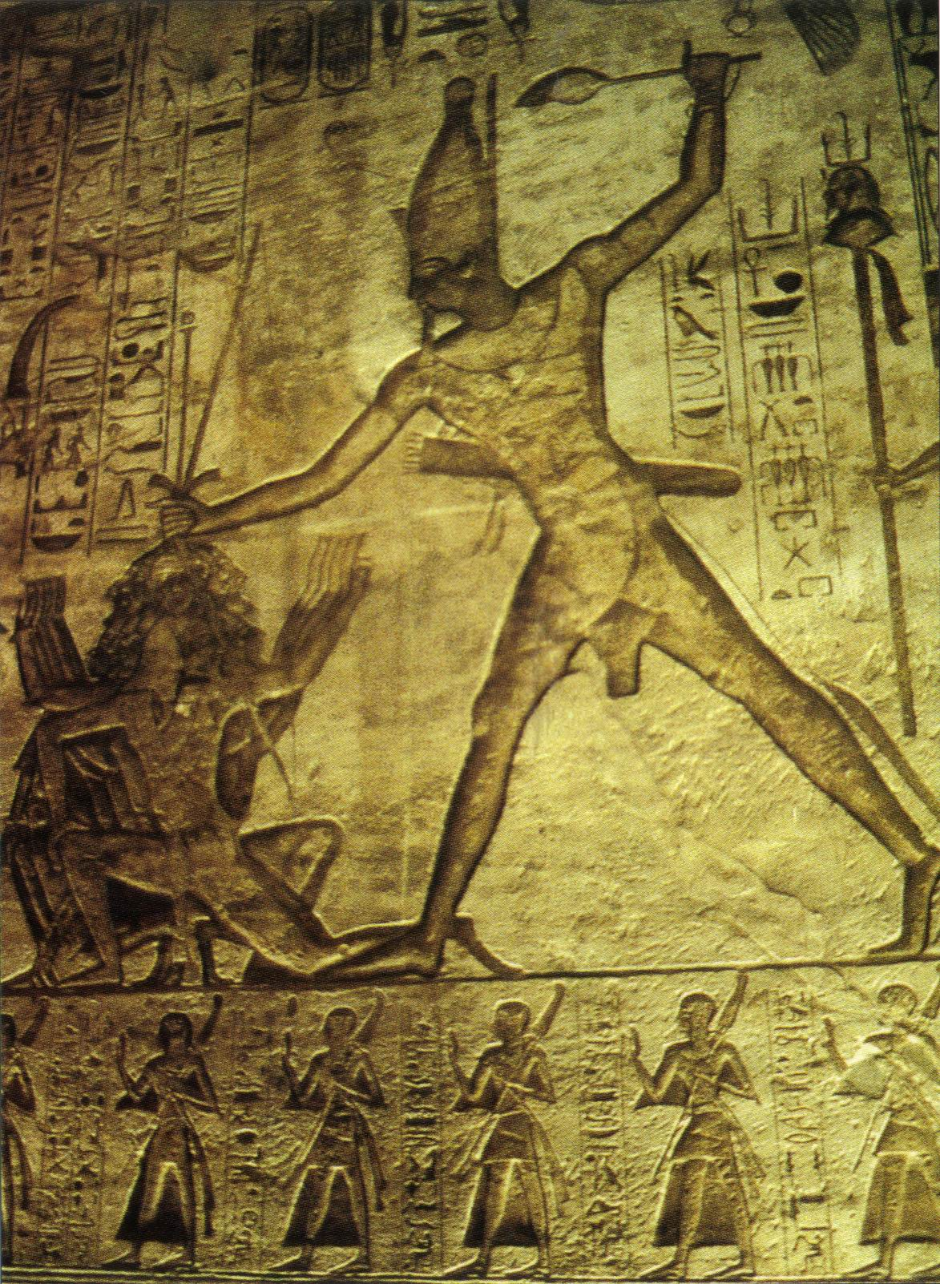

( Figure 1. Ramses 11. Oakes and Gahlin. 2002: 207)

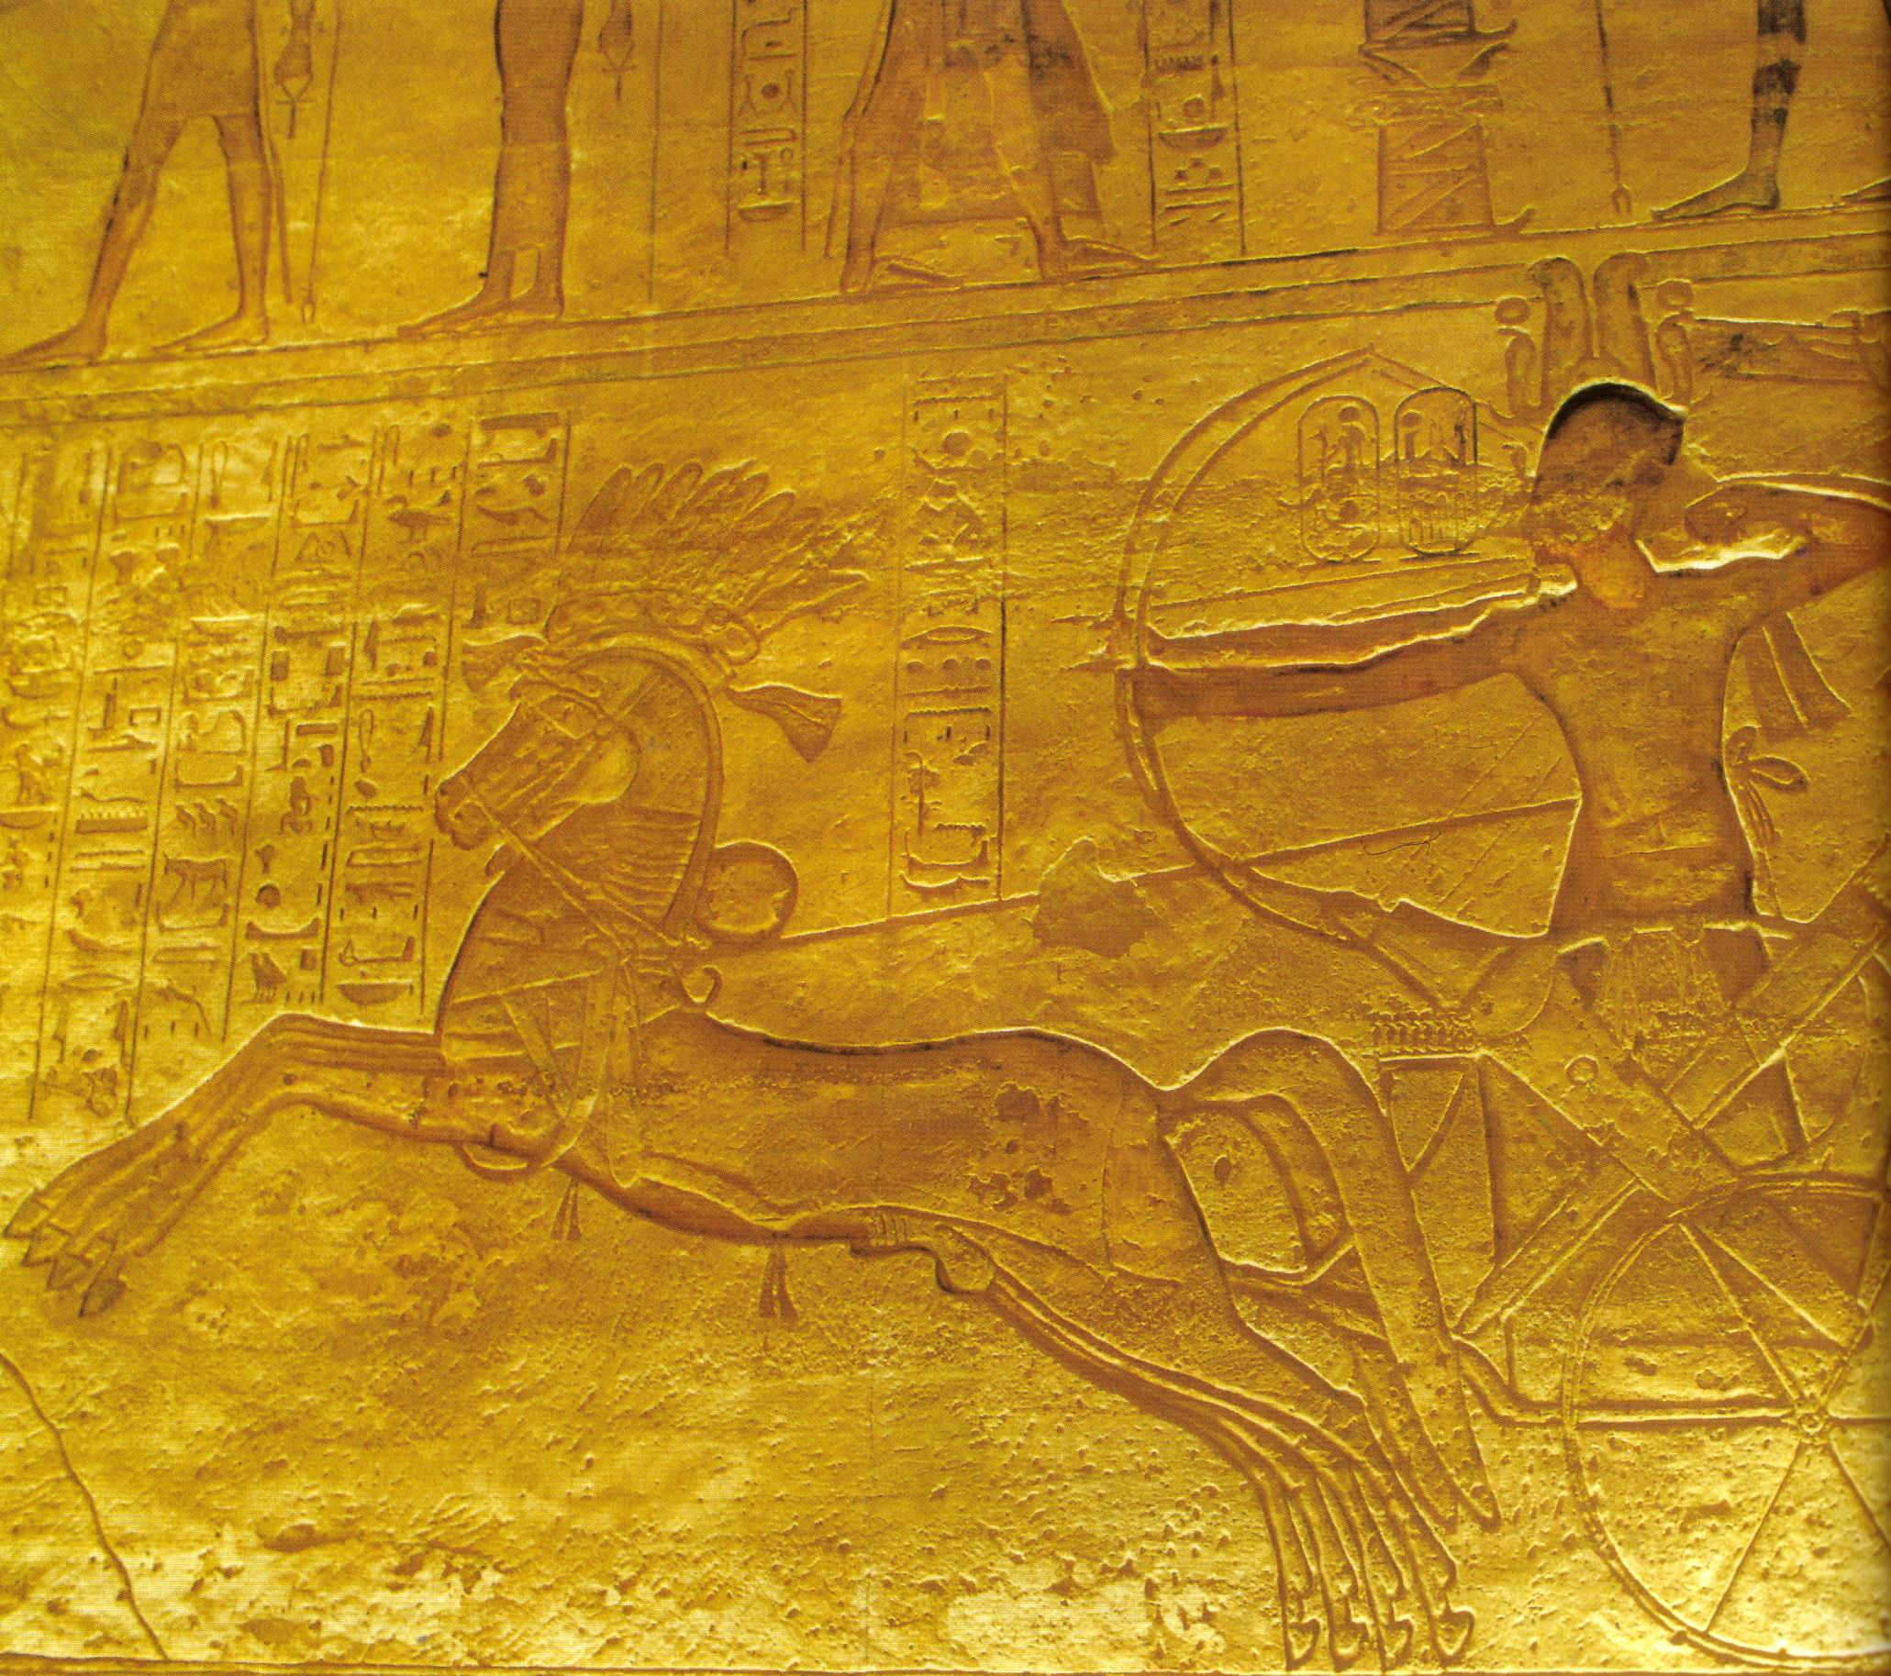
(Figure 2. Ramses 11. Davies and Friedman. 1998: 146)

This is a reconstruction of them.

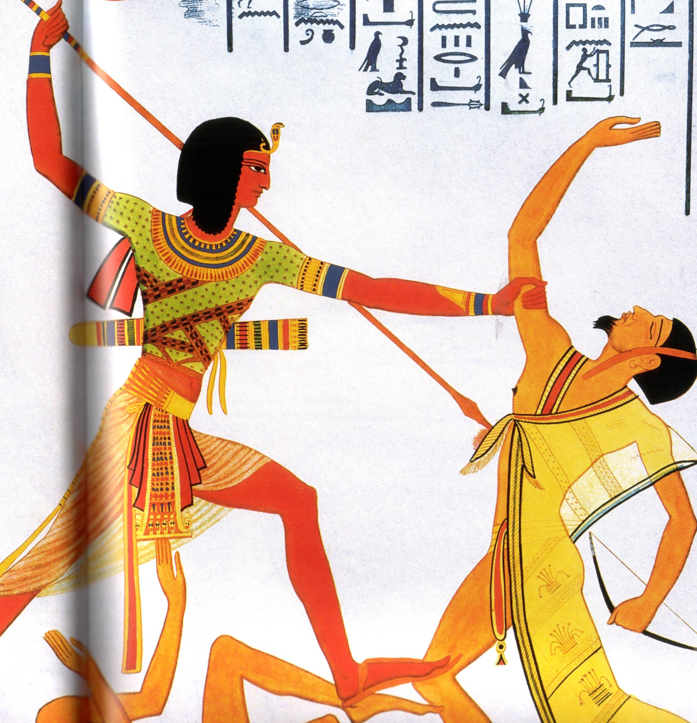
( Figure 3. Gros de Beler. 2004: 27)

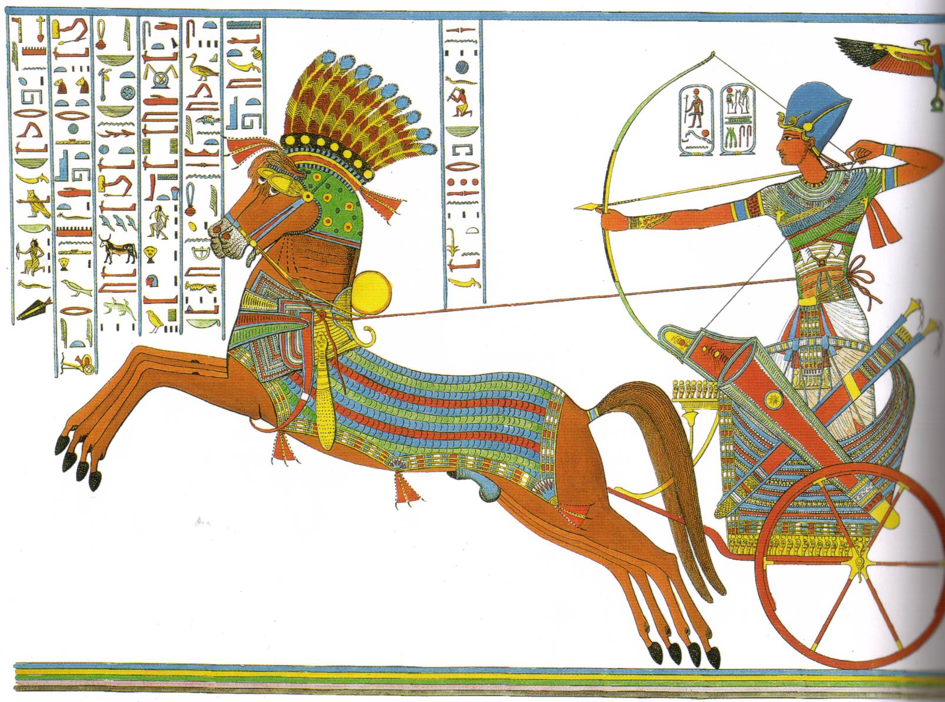
(Figure 4. Wilkinson. 2000: 228)

This is what is contained in them.
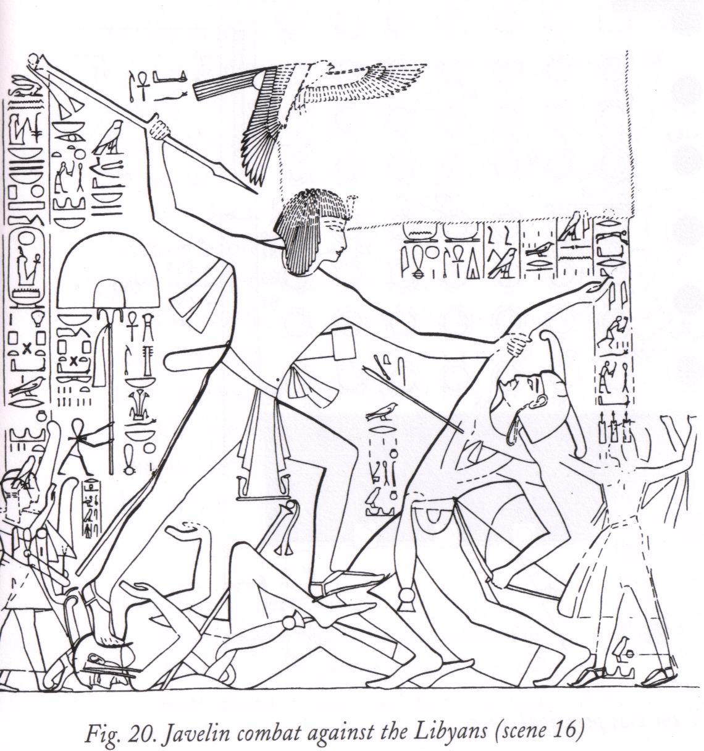
( Figure 5. Schwaller de Lubicz. 1999: 561)

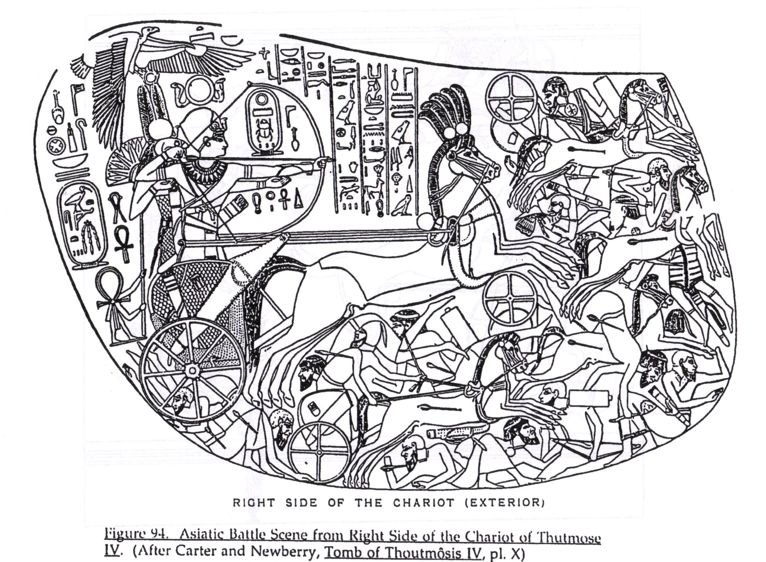
( Figure 6. Harvey.1998: 547)

In both, the king is the largest figure and the centre of the action. He is beating down his enemies through his own personal efforts. He is fit, strong, aggressive, seemingly skilful, brave, young and active. The scene as a whole is dramatic and filled with sound and fury but it shows a king on the ground, on the same surface as both his enemies and his own forces. He is strong and kingly but he is one individual among many and his power is very personal. The focus is narrow and tells only the immediate part of the story and it is confined to one place. Compare it to the image of Thutmose 1V. The horse and chariot lift the king above the action; he is now well above all other combatants. Together with the king the horses and chariot are shown on a much larger scale than any other and the combination enables the king’s image to dominate the scene even more effectively. He is still fit, strong, aggressive, skilful, brave, young and active but now he is charging into battle at great speed aboard an amazing vehicle with the reins of two huge powerful stallions tied around his waist and is able because of the scale difference to crush proportionally more enemies under the feet of his horses. The dramatic action has been enhanced tremendously. The prestige of possessing horses, their nobility and raw natural power and energy has attached to the king and enhanced his image as conqueror. The “flying gallop” posture of the horses (an image which appears to owe much to Minoan influence) exudes power and speed. The magnificent chariot and harnesses of the horses contribute more colour and also a clear statement about the king’s possession of the newest technological innovations and his enhanced mobility. This is a much more impressive and indeed exciting scene.

Ray Johnson has reconstructed an Asiatic scene from Thebes depicting Tutankhamun in battle. ( Johnson. 1992: 188) In this more traditional elements are mixed with the new when an Asiatic city is attacked by the massed chariot regiments of the king whose horses trample the enemy underfoot and whose massed chariot warriors attack and defeat a walled city. The Egyptians developed the new type of image and embarked on dramatic narrative beyond what was achieved in the past and enabled the image to embrace the whole event, which as a result takes on epic proportions.

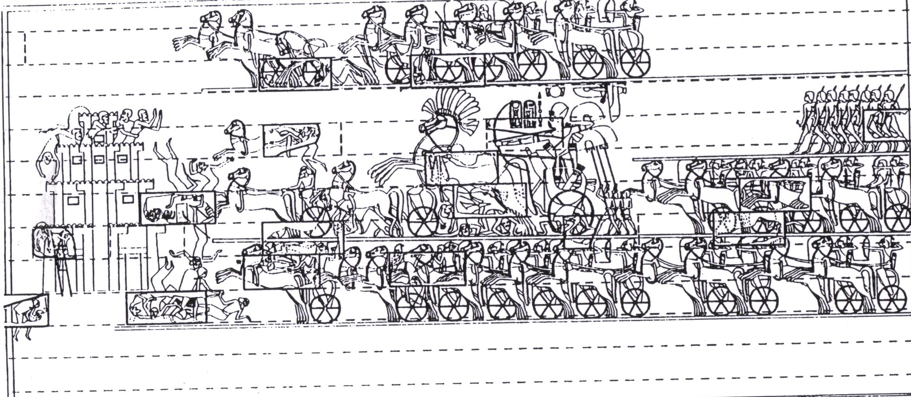
( Figure 7. Johnson.1992:188)

The various kings of Egypt may not have maintained Maat in reality - but with the use of images like this, those who viewed them were persuaded that they did. Horses and chariots were silent partners in creating the reality and the perception of the power of the king in ancient Egypt.

References.

Baines. J. (1995) Kingship, Definition of Culture and Legitimation. in O’Connor. D. and Silverman. D. (Eds.) Ancient Egyptian Kingship. Leiden: NewYork: E.J. Brill.

Bietak. M. (1996). Avaris. Capital of the Hyksos.
British Museum Press. London.

Davies. N. de G. (2004) The Rock Tombs of El Amarna. Egypt Exploration Society. London.

Davies.V. and
Freedman. R. (1998) Egypt. British Museum Press. London.

Fletcher. J. ( 2000) Egypt’s Sun King. Amenhotep 111. D. Baird. London.

Freed.R, Markowitz.Y
and D’Auria. (Eds). (2000) Pharaohs of the Sun. Bulfinch Press. Boston.

Grimal. N. (1997) A History of Ancient Egypt. Blackwell. Oxford.

Gros de Beler. A. (2004) Pharaohs. Grange Books. Kent.

Gutgesell. M (1998) The Military. In Schulz.R. and Seidel.M. Egypt. World of the Pharaohs. Konemann. Cologne.

( 1998) Economy and Trade. In Schulz. R. and Seidel. M. Egypt. World of the Pharaohs. Konemann. Cologne.

Harvey. S. (1998) The Cults of King Ahmose at Abydos. ( Dissertation.) University of Pennsylvania.

Johnson. R. (1992) An Asiatic Battle Scene of Tutankhamun from Thebes.
( Dissertation) University of Chicago. Chicago. Illinois.

Oakes.L. and Gahlin.L. (2002) Ancient Egypt. Hermes House. London.

Malek. J. (1986). In the Shadow of the Pyramids. University of Oklahoma Press. Oklahoma.

Pardey. E. (1998) The Royal Administration and Its Organization. in Schulz. R. and Seidel. M. Egypt. The World of the Pharaohs. Konemann. Cologne.

Redford. D. (1995) The Concept of Kingship During the Eighteenth Dynasty. in O’Connor. D. and Silverman. D. (Eds.) Ancient Egyptian Kingship. Leiden: New York: E.J. Brill.

Robins. G. (1997) The Art of Ancient Egypt. Harvard University Press. Massachusetts.

Schneider.T. (1998) The Nature of Egyptian Kingship. In Schulz. R. and Seidel. M. Egypt. World of the Pharaohs. Konemann. Cologne.

Schwaller de Lubicz. R. (1999) The Temples of Karnak. Thames and Hudson. London.

Shafer. B. (Ed) (1991) Religion in Ancient Egypt. Cornell University Press. New York.

Silverman. D. (1995) The Nature of Egyptian Kingship. in O’Connor. D. and Silverman. D. (Eds.) Ancient Egyptian Kingship. Leiden: New York: E. J. Brill.

Simpson. W. K. (2003) The Literature of Ancient Egypt. Yale University Press. New Haven.

Steindorff. G. and
Seele. K. (1957) When Egypt Ruled the East. University of Chicago Press. Chicago.

Time-Life. (1993) Ramses 11. Magnificence on the Nile. Time-Life Books. Alexandria. Virginia.

Trigger. B, Kemp. B,
O’Connor. D., Lloyd. A. (2001) Ancient Egypt. A Social History. Cambridge University Press. Cambridge.

Watterson. B. (1999) Gods of Ancient Egypt. Bromley Books Ltd. Surrey.

Wilkinson. R. (2000) The Complete Temples of Ancient Egypt. Thames and Hudson. London.

Wilkinson. T. (2003) Early Dynastic Egypt. Routledge. London.

Woldering. I. (1965) The Art of Egypt. Crown Publishers. New York.

(1967) The Arts of Egypt. Thames and Hudson. London.

